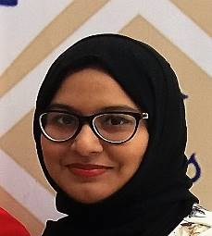
NAVIRA YASMEEN SHAFIQ
_______________________________________________

Objective: Seeking an suitable assignment in Banking / Finance / Accounting/ Management accounting

EDUCATIONAL PROFILE

- Graduate in Banking, Finance & Accounting from the University of Bahrain, Kingdom of Bahrain.(2018)
- Grade 12 from Pakistan Urdu School, Kingdom of Bahrain.(2013)
AREAS OF WORK EXPOSURE
Internship in Orange Suites, Hotel & Apartments (Accounts Dept.)
- Working knowledge of Tally ERP 9.
- Credit card statement analysis.
- Invoice rechecking

IT SKILLS

- Good knowledge of MS Office applications including Word, Excel and Power point. Well versed in Internet.

INTERESTS AND ACTIVITIES

- Reading:
Like to Read all kinds of literature including current affairs to keep myself abreast with the happenings around the world.

- Writing:
I have keen interest and am skillful in report writing & editing.

- Communication:
Communication is a very important tool in industry and I have developed good communication skills.

LANGUAGES

- Urdu (mother tongue), Hindi & English.

PERSONAL DETAILS

- Date of Birth: 21st February 1995

- Nationality: Pakistani

- Marital Status: Single

- Contact Address: Flat 12, Building 2199, Block 306, Road 647, Manama, Kingdom of Bahrain

- Contact Number: 34047571

- Email: navira.1995@gmail.com

- Holding valid Bahrain driving License.

